## Part A:

Use the following code to create the three tables for this database. Copy and paste this code into SQL Developer and run the script.

| CREATE TABLE YOUTUBERINFO (  rank NUMBER,  rank_in_country NUMBER,  youtuber VARCHAR2(255),  category VARCHAR2(255),  uploads NUMBER,  Country VARCHAR2(255),  channel_type VARCHAR(255),  created_date DATE,  PRIMARY KEY (youtuber)  );  CREATE TABLE COUNTRYSTATS (  countryID NUMBER,  Country VARCHAR2(255),  population NUMBER,  PRIMARY KEY (Country)  );  CREATE TABLE channel_stats (  CHANNEL_ID NUMBER PRIMARY KEY,  RANK NUMBER,  YOUTUBER VARCHAR2(255),  SUBSCRIBERS NUMBER,  VIDEO_VIEWS NUMBER,  LOWEST_YEARLY_EARNINGS NUMBER,  HIGHEST_YEARLY_EARNINGS NUMBER,  Country VARCHAR2(255),  FOREIGN KEY (YOUTUBER) REFERENCES YOUTUBERINFO(youtuber),  FOREIGN KEY (Country) REFERENCES COUNTRYSTATS(Country)  ); |
| --- |

## 

## Part B:

1. Create Tables:

* Run above queries to create tables
* Right click “Tables” under “CNIT372 Connection” tab and click “refresh” to display the tables created
* Create YouTuberInfo first, Channel_Stats second, and country_stats last.
  + This order is important to ensure the Primary Keys are established correctly

1. Import Data from Worksheets:

* Right click the table in the Connections Tab and click “Import Data…”
* Locate the data file from your computer by clicking the “Browse” button
* Select the corresponding sheet.
* Click “Next” and fill out the remaining information as needed.
* Repeat this step for each worksheet/table.

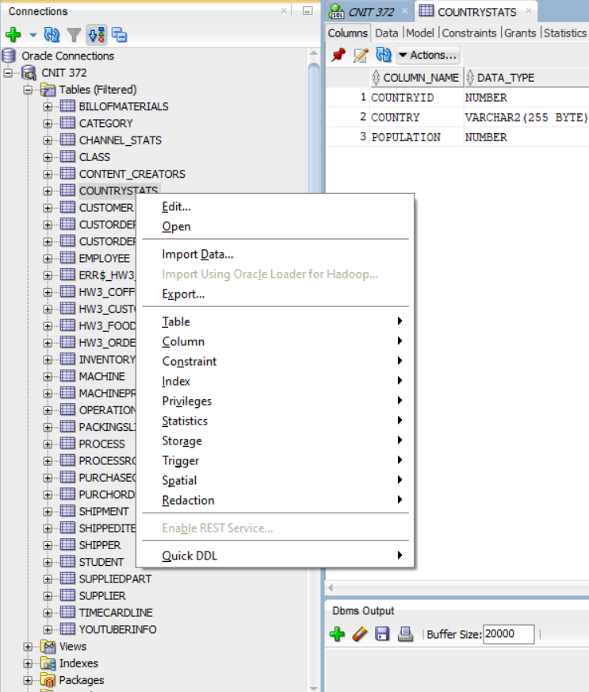

Right clicking the table for “Import Data…”

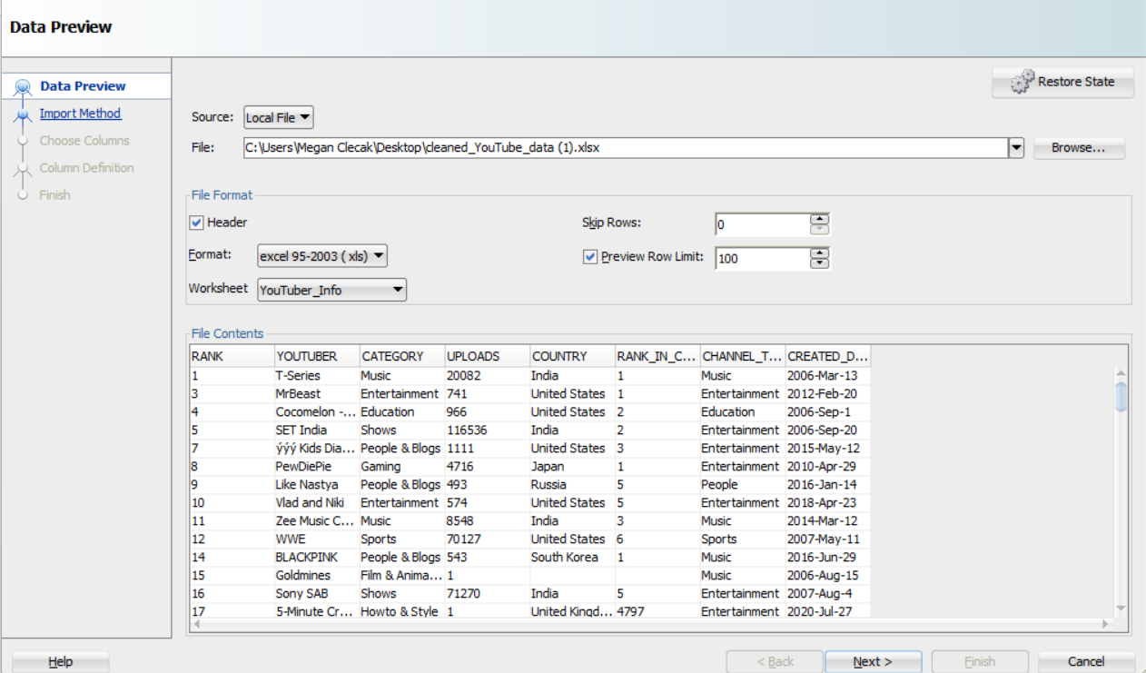

In the “Worksheet” dropdown, select the correct worksheet for the corresponding table being created.